Experiment:9
Aim:
To write a Python program to solve the Travelling Salesman Problem using brute-force search.
Algorithm:
- Start the program.
- Store the distances between cities in a graph.
- Select the starting city.
- Generate all possible permutations of the remaining cities.
- Calculate the total distance for each route, returning to the starting city.
- Compare the route costs and find the minimum cost.
- Display the shortest path and minimum cost.
- Stop.
Code:
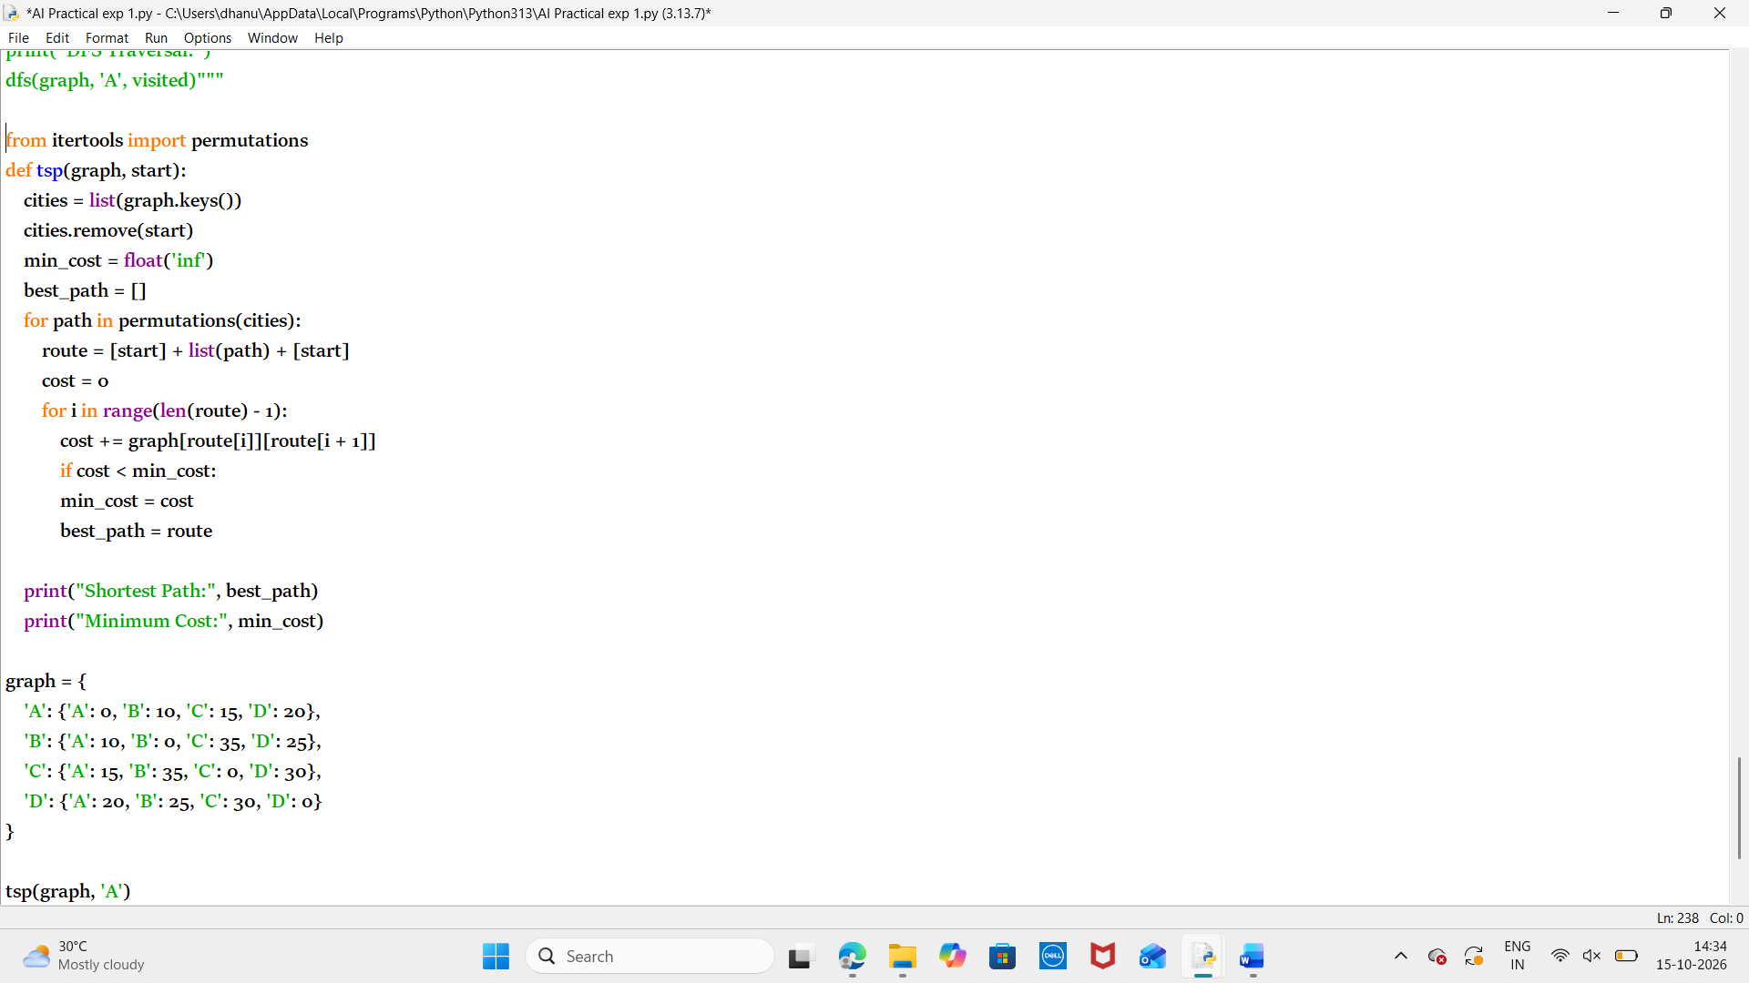
Output:
Result:
Thus the python program to solve the travelling salesman problem is executed successfully.

